The Mid-West Children Network Teams 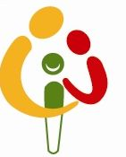
Lets Talk: Working Together for a Better Service


We are committed to using your feedback to help us to improve the service for everyone.
If you would like a member of staff to contact you , please provide your name and contact details :
What are we doing well?

What can we do better?

Which team is your child attending?
Early Intervention
School Age

